University of Minnesota
Brad McDonald
12920 103RD ST N
Stillwater MN 55082
USA
Invoice number: 25031 St.Gallen, 30 July 2025
Invoice date: 30 Jul 2025 Invoice: NIPO data purchase for academic purposes
Due date: 29 Aug 2025

Dear Mr. McDonald

In accordance with our agreement, we hereby issue an invoice for an academic purchase of the New Industrial Policy Observatory. The NIPO dataset for August 2025 will be delivered shortly.

Purchase fee: CHF 500.00
Invoice total: CHF 500.00

Please transfer this amount in full to the following bank account:

Account Holder: St.Gallen Endowment for Prosperity through Trade
Bank name: St.Galler Kantonalbank
IBAN: CH80 0078 1624 8968 1200 0
BIC: KBSGCH22

Alternatively, you can also pay by credit card.

Your support for the St.Gallen Endowment is highly appreciated.

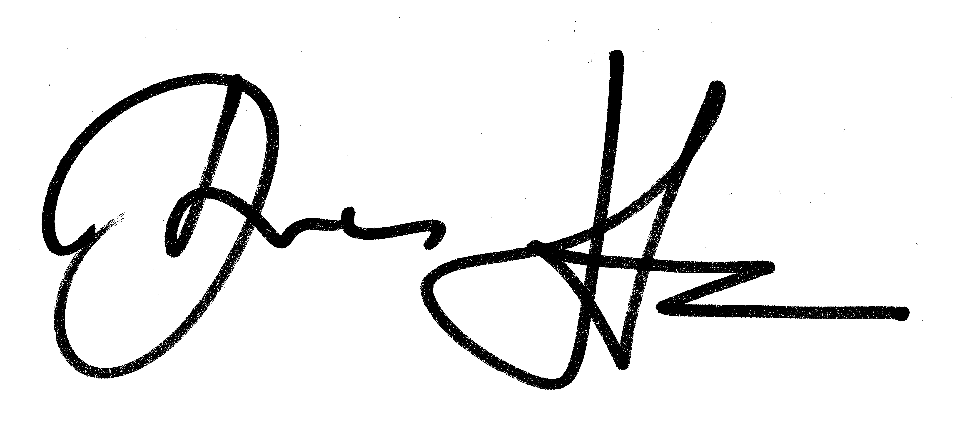
Best regards

